**NAME:**  Sudharshan R 185001173

**EX-NO:** 3

**EX-NAME:** Website for international Peace conference using html and CSS.

**Date:17-2-2020**

**OBJECTIVE:**

**3A) Form using CSS and Java Script**

Generate a registration form for a hospital to register new patient details. Validate the form elements. Ex: Name should be only alphabet, address only alpha-numeric character. “required” for all fields etc.

**3B) Memory Game time bounded**

Write a JS program to develop a memory matching game.

**INDEX.HTML:**

<!DOCTYPE html>

<html>

<head>

<title>Ex3</title>

<link rel="stylesheet" href="home_style.css">

</head>

<body>

<button class="upper" onclick="window.location.href='clinic.html';">Clinic Form</button>

<button class="lower" onclick="window.location.href='Memory_game.html';">Memory Game</button>

</body>

</html>

**HOME_STYLE.CSS:**

body{

background-color:gold;

text-align:centre;

}

button{

background-color:black;

color:aqua;

width:35%;

height:25%;

margin: 0;

position: absolute;

font-size:30px;

left: 50%;

-ms-transform: translate(-50%, -50%);

transform: translate(-50%, -50%);

}

.upper{

top: 35%;

}

.lower{

top: 65%;

}

**CLINIC.HTML:**

<!DOCTYPE html>

<html>

<head>

<title>JS Form</title>

<link rel="stylesheet" href="Formstyle.css">

<script src="Formscript.js" ></script>

</head>

<body onload="startTime()">

<div id="clk" class = "clock"></div>

<form action="#" method="post" target="_blank">

<h1 class="centre"><em><span style="font-size:36px;">C</span>LINICAL <span style="font-size:36px;">D</span>ETAILS</em></h1>

<label for="fname">Name:</label><br><br>

<input type="text" id="fname" oninvalid="alert('Name must be only alphabets and between 1 and 32 characters');" pattern="[A-Za-z ]{1,32}" onblur="this.checkValidity();" name="fname" required><br><br>

<label for ="addr">Address:</label><br><br>

<textarea id="addr" name="addr" rows="4" cols="50" onfocus="this.value ='';" onselect="document.getElementById('adr').innerHTML = 'You have entered address';" oninvalid="alert('address must be only alphanumeric');" pattern="[A-Za-z 0-9]{1,}" onblur="this.checkValidity();" required> Enter your permanent address

</textarea><br><br>

<p id="adr"></p>

</textarea>

<label for="age">Age(in years):</label><br><br>

<input type="number" id="age" name="age" value="0" min="0" max="100" required onkeypress="alert('use navigators');"><br><br>

<label for="dob">Date of Birth:</label>

<input type="date" id="dob" name="dob" required><br><br>

<p>Please select your gender:</p>

<input type="radio" id="male" name="gender" value="male" required>

<label for="male">Male</label><br>

<input type="radio" id="female" name="gender" value="female">

<label for="female">Female</label><br>

<input type="radio" id="other" name="gender" value="other">

<label for="other">Other</label><br><br>

<label for="ms">Marital Status:</label>

<select name="ms" id="ms" onchange="msd()" required>

<option value="Bachelor">Bachelor</option>

<option value="Married">Married</option>

<option value="Spinster">Spinster</option>

<option value="Widow">Widow</option>

</select>

<p id ="status"></p>

<br><br>

<label for="phone">Contact Number (mobile):</label>

<input type="tel" id="phone" name="phone" pattern="[0-9]{5}-[0-9]{5}" oninvalid="alert('match the pattern properly');" required><br>

<p style="color:grey;">example : 12345-67890</p><br>

<label for ="addc">Addiction:</label><br>

<div id="div1" ondrop="drop(event)" ondragover="allowDrop(event)">

<ul>

<li draggable="true" ondragstart="drag(event)" id="drag1">Drugs</li>

<li draggable="true" ondragstart="drag(event)" id="drag2">Alcoholism</li>

<li draggable="true" ondragstart="drag(event)" id="drag3">Nicotine Products</li>

</ul>

</div>

<div id="div2" ondrop="drop(event)" ondragover="allowDrop(event)"></div>

<br><br><br><br><br><br><br><br><br>

<input type="submit" value="Submit" onclick="display();">

<input type="reset" value="Reset" onclick='customreset();'>

</form>

</body>

</html>

**FORMSTYLE.CSS:**

input, select,textarea {

width: 50%;

padding: 12px 20px;

margin-left:auto;

margin-right:auto;

display: inline-block;

border: 1px solid #ccc;

border-radius: 4px;

box-sizing: border-box;

background-color:#DFF9F4;

}

input[type=radio]{

width:5%;

}

input:hover,textarea:hover,select:hover{

background-color:#CED4D4;

}

.centre {

      text-align: center;

    }

h1{

color:red;

font-size:24px;

letter-spacing: 1.5px;

text-shadow: 2px 2px black;

font-family: Arial, Helvetica, sans-serif;

}

input[type=submit] {

width: 25%;

background-color: #4CAF50;

color: white;

padding: 14px 20px;

margin-left:auto;

margin-right:auto;

border: none;

border-radius: 4px;

cursor: pointer;

}

input[type=reset] {

width: 25%;

background-color: #4CAF50;

color: white;

padding: 14px 20px;

margin-left:auto;

margin-right:auto;

border: none;

border-radius: 4px;

cursor: pointer;

}

input[type=submit]:hover {

background-color: #45a049;

}

input[type=reset]:hover {

background-color: #45a049;

}

body{

  background-color:gold;

  padding-left:50px;

}

.clock{

  color:aqua;

  font-size:24px;

  float:right;

  padding-right:50px;

background-color: black;

}

#div1, #div2

{

float: left;

width: 150px;

height: 100px;

margin: 10px;

padding: 10px;

border: 2px solid black;

background-color: white;

}

table{

border-width:2px;

border-collapse:collapse;

margin-left :auto;

margin-right :auto;

}

thead{

background-color:bisque;

}

  .centre {

      text-align: center;

    }

td{

margin-left :auto;

margin-right: auto;

padding-left: 15px;

border:2px solid black;

border-collapse:collapse;

}

tr:hover

{

background-color: white;

}

**FORMSCRIPT.JS:**

function allowDrop(ev)

{

ev.preventDefault();

}

function drag(ev)

{

ev.dataTransfer.setData("text", ev.target.id);

}

function drop(ev)

{

ev.preventDefault();

var data = ev.dataTransfer.getData("text");

ev.target.appendChild(document.getElementById(data));

}

function msd() {

var x = document.getElementById("ms").value;

document.getElementById("status").innerHTML = "You selected: " + x;

}

function startTime() {

var today = new Date();

var h = today.getHours();

var m = today.getMinutes();

var s = today.getSeconds();

m = checkTime(m);

s = checkTime(s);

document.getElementById('clk').innerHTML =

h + ":" + m + ":" + s;

var t = setTimeout(startTime, 500);

}

function checkTime(i) {

if (i < 10) {i = "0" + i}; // add zero in front of numbers < 10

return i;

}

function display()

{

var name=document.getElementById("fname").value;

var addr=document.getElementById("addr").value;

var age=document.getElementById("age").value;

var dob=document.getElementById("dob").value;

var ms=document.getElementById("ms").value;

var gender=document.querySelector('input[name="gender"]:checked').value;

var contact=document.getElementById("phone").value;

var addiction=document.getElementById("div2").innerHTML;

document.writeln("<link rel=\"stylesheet\" href=\"Formstyle.css\">")

document.writeln( "<h1 style=\"text-align:center;\">Details</h1>" );

document.writeln( "<table border = \"1\" width = \"50%\">" );

document.writeln( "<tr><th>ID</th><th>Value</th></tr>");

document.writeln("<tr><td>NAME</td><td>"+name+"</td></tr>");

document.writeln("<tr><td>ADDRESS</td><td>"+addr+"</td></tr>");

document.writeln("<tr><td>AGE</td><td>"+age+"</td></tr>");

document.writeln("<tr><td>D.O.B</td><td>"+dob+"</td></tr>");

document.writeln("<tr><td>MS</td><td>"+ms+"</td></tr>");

document.writeln("<tr><td>GENDER</td><td>"+gender+"</td></tr>");

document.writeln("<tr><td>CONTACT</td><td>"+contact+"</td></tr>");

document.writeln("<tr><td>ADDICTION </td><td>"+addiction+"</td></tr>");

document.writeln( "</table>" );

}

function customreset()

{

document.getElementById("div1").innerHTML+=document.getElementById("div2").innerHTML;

document.getElementById("div2").innerHTML='';

alert('form has been reset');

}

**MEMORY_GAME.HTML:**

<!DOCTYPE html>

<html>

<head>

<title>Memory Game</title>

<link rel="stylesheet" href="gamestyle.css">

</head>

<body onload="initiate(1);">

<div class="upper"><p id = "score"> 0 </div>

<div class="lower"><p id="counter"></div>

<button id="1"><img id='img1' src='cover.jpeg' alt='card 1'></button>

<button id="2"><img id='img2' src='cover.jpeg' alt='card 2'></button>

<button id="3"><img id='img3' src='cover.jpeg' alt='card 3'></button>

<button id="4"><img id='img4' src='cover.jpeg' alt='card 4'></button>

<button id="5"><img id='img5' src='cover.jpeg' alt='card 5'></button>

<br><br><br><br>

<button id="6"><img id='img6' src='cover.jpeg' alt='card 6'></button>

<button id="7"><img id='img7' src='cover.jpeg' alt='card 7'></button>

<button id="8"><img id='img8' src='cover.jpeg' alt='card 8'></button>

<button id="9"><img id='img9' src='cover.jpeg' alt='card 9'></button>

<button id="10"><img id='img10' src='cover.jpeg' alt='card 10'></button>

<script src="gamescript.js" ></script>

</body>

**GAMESTYLE.CSS:**

img{

height:200px;

width:150px;

}

body{

background-color:gold;

padding-left:150px;

padding-top:100px;

}

div{

width:100px;

height:60px;

background-color:black;

position: absolute;

right:200px;

align-content: center;

}

.upper{

top: 25%;

}

.lower{

top: 60%;

}

p{

color:aqua;

font-size:30px;

position:relative;

left:40px;

top:-15px;

}

button{

border:none;

background-color: gold;

height: 210px;

width:160px;

}

**GAMESCRIPT.JS:**

let list = [1, 2, 3, 4, 5, 1, 2, 3, 4, 5]

var select=[-1,-1];

var tc=0;

var counter,ttime;

var match=0;

var cover=[1,1,1,1,1,1,1,1,1,1];

var score=0;

var level;

document.getElementById("1").addEventListener("click", function(){cal(1);});

document.getElementById("2").addEventListener("click", function(){cal(2);});

document.getElementById("3").addEventListener("click", function(){cal(3);});

document.getElementById("4").addEventListener("click", function(){cal(4);});

document.getElementById("5").addEventListener("click", function(){cal(5);});

document.getElementById("6").addEventListener("click", function(){cal(6);});

document.getElementById("7").addEventListener("click", function(){cal(7);});

document.getElementById("8").addEventListener("click", function(){cal(8);});

document.getElementById("9").addEventListener("click", function(){cal(9);});

document.getElementById("10").addEventListener("click", function(){cal(10);});

function setlevel(x)

{

list = list.sort(() => Math.random() - 0.5);

select=[-1,-1];

tc=0;

if(x==1){

ttime=60;

}

else if(x==2){

ttime=45;

}

else if(x==3){

ttime=30;

}

match=0;

var i;

cover=[1,1,1,1,1,1,1,1,1,1];

level=x;

for(i=1;i<=10;i++)

{

document.getElementById("img"+i).src="cover.jpeg";

document.getElementById("img"+i).style.display="block";

}

}

function cal(x){

if(cover[x-1]==1){

if(select[0]==-1)

{

select[0]=x;

document.getElementById("img"+x).src= "img"+list[x-1]+".jpeg";

cover[x-1]=0;

}

else if(select[1]==-1)

{

select[1]=x;

document.getElementById("img"+x).src= "img"+list[x-1]+".jpeg";

cover[x-1]=0;

setTimeout(eval,1000);

}

}

}

function eval()

{

if(document.getElementById("img"+select[0]).src==document.getElementById("img"+select[1]).src){

score+=20;

document.getElementById("img"+select[0]).style.display="none";

document.getElementById("img"+select[1]).style.display="none";

select[0]=-1;

select[1]=-1;

match+=1;

}

else

{

score-=5;

document.getElementById("img"+select[0]).src="cover.jpeg";

document.getElementById("img"+select[1]).src="cover.jpeg";

cover[select[0]-1]=1;

cover[select[1]-1]=1;

select[0]=-1;

select[1]=-1;

}

}

function initiate(x)

{

alert('Welcome\nFind all possible pairs within given time\n correct match : +20 points wrong match : -5 points\nEarly finish would give extra time points to the score \nlevel='+x);

setlevel(x);

counter=setInterval(countdown,1000);

}

function countdown()

{

tc++;

document.getElementById("counter").innerHTML=ttime-tc;

document.getElementById("score").innerHTML=score;

if(ttime-tc==0)

{

clearInterval(counter);

if(level==3)

alert("GameOver:\n Game Score:"+score);

else

initiate(level+1);

}

else if(match==5)

{

clearInterval(counter);

score+=ttime-tc;

var tl=ttime-tc;

document.getElementById("score").innerHTML=score;

if(level==3)

alert("GameOver:\n Game Score:"+score);

else

initiate(level+1);

}

}

**IMAGES ADDED IN WEBSITE:**

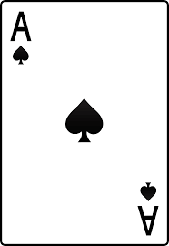 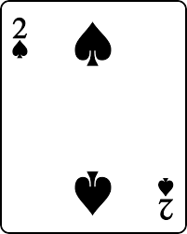

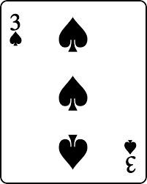 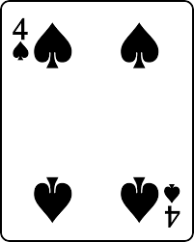

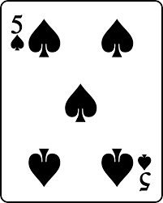 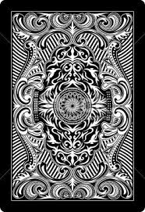

**WEBSITE OUTPUT SCREENSHOTS:**

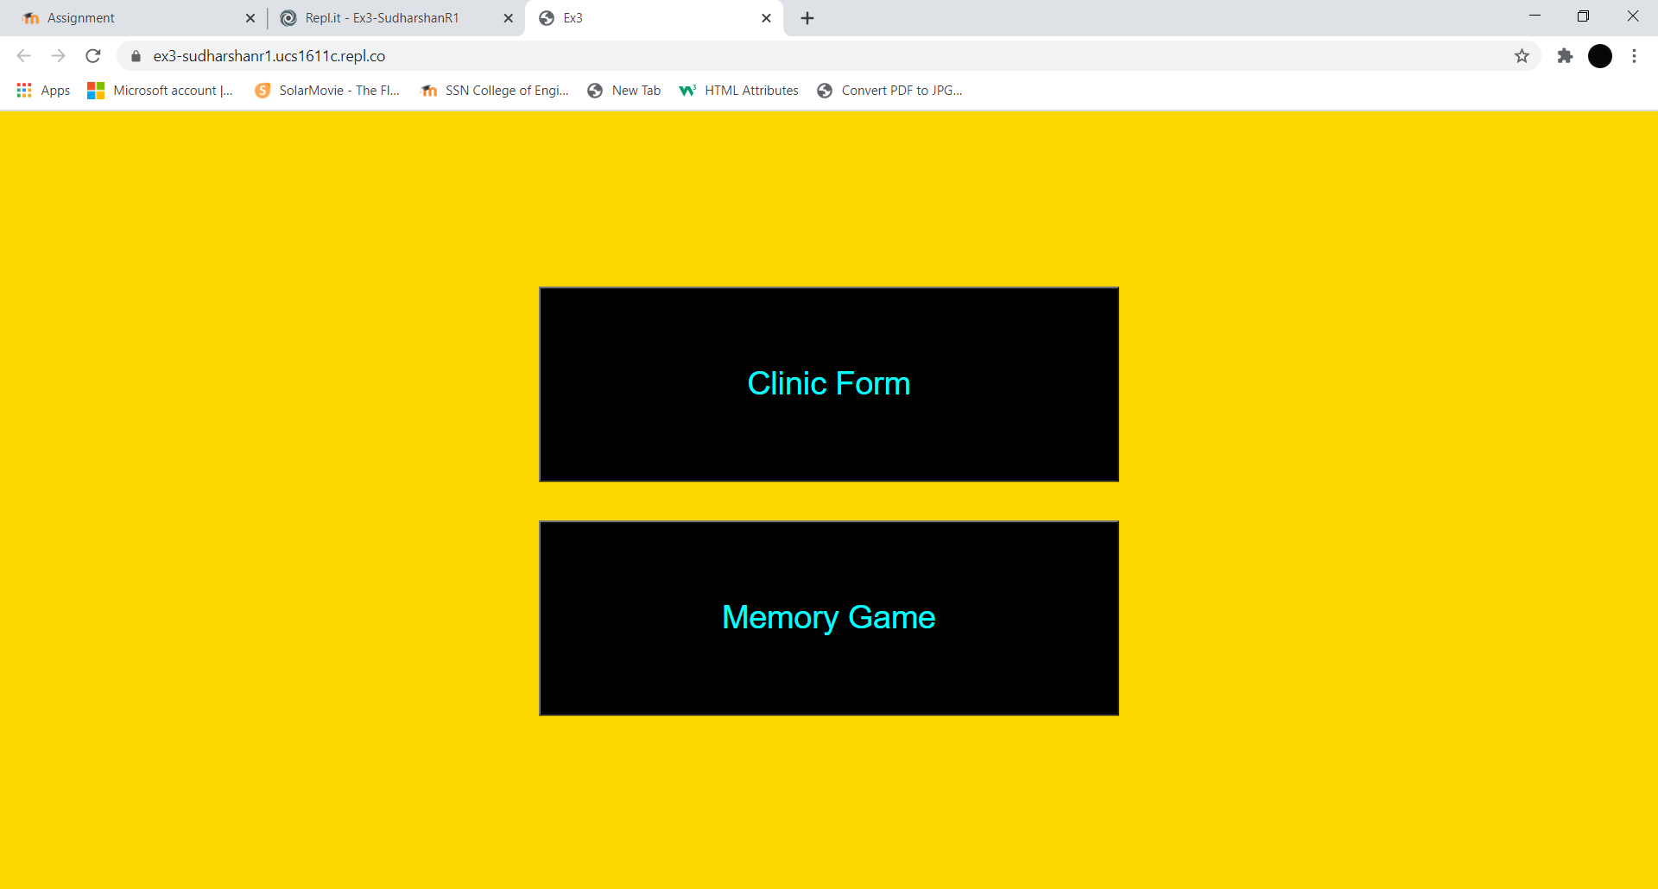

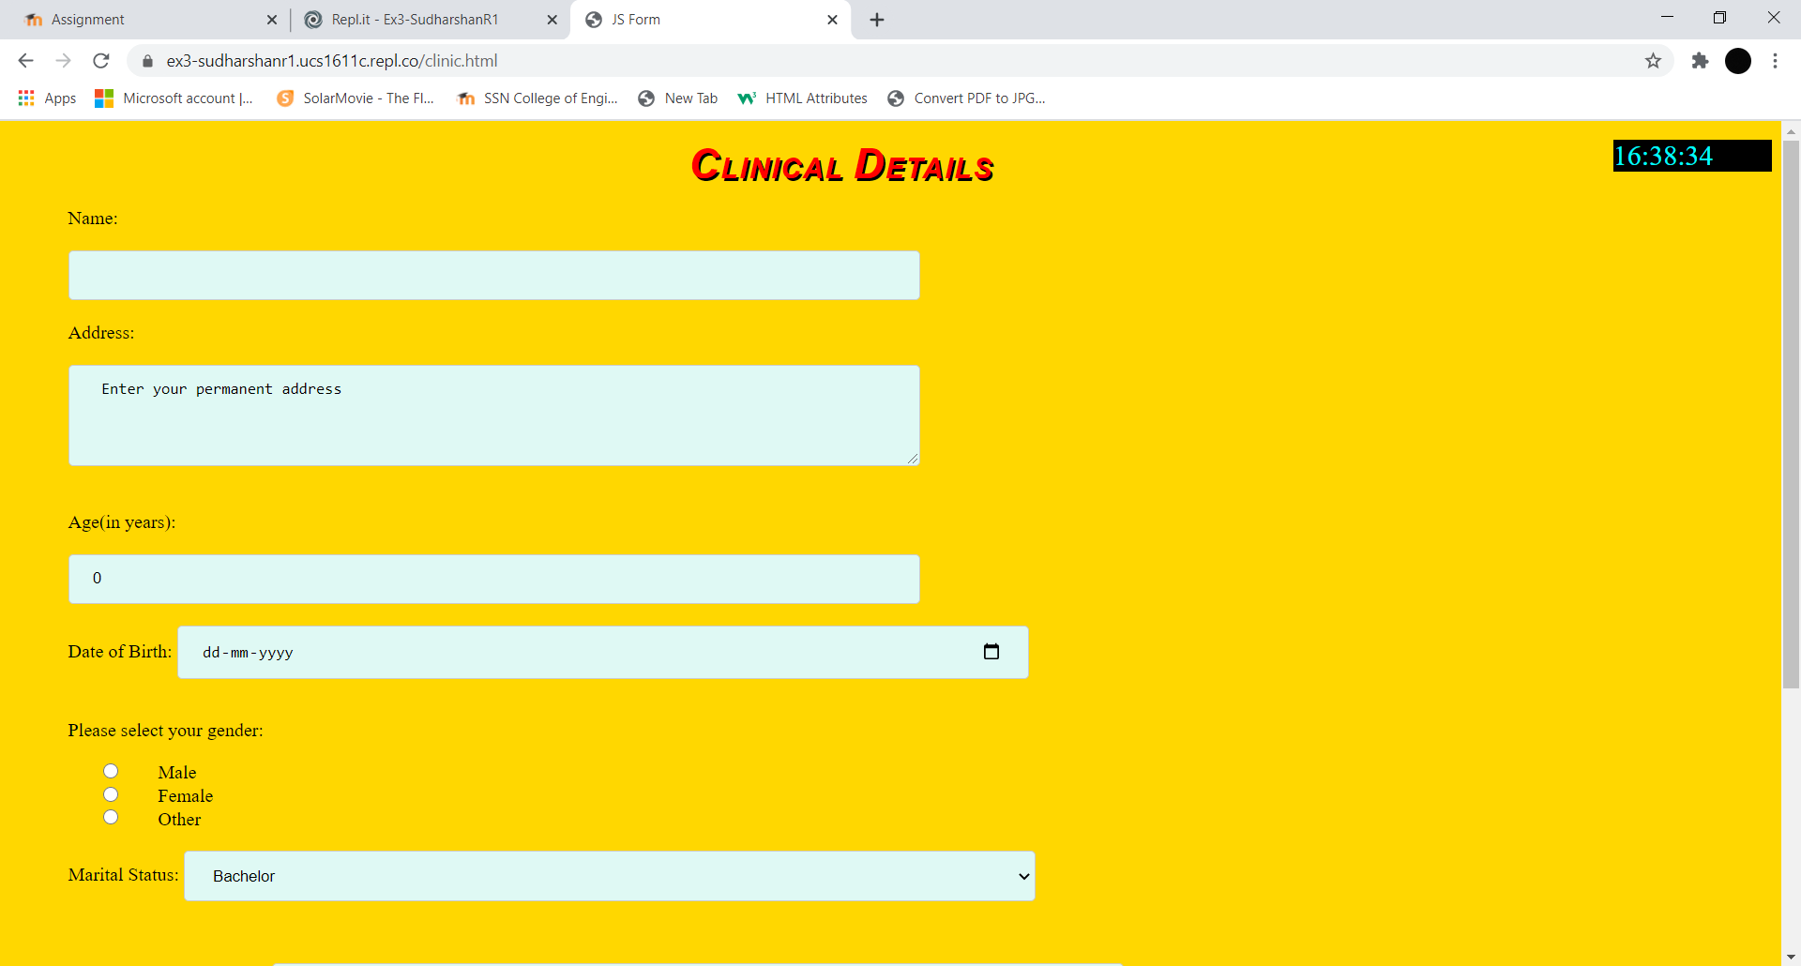

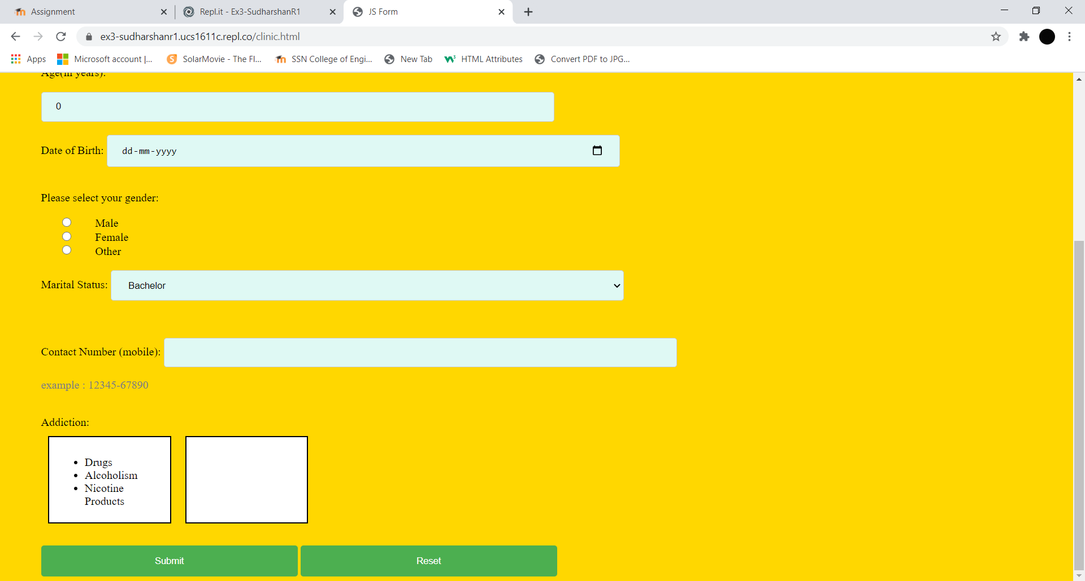

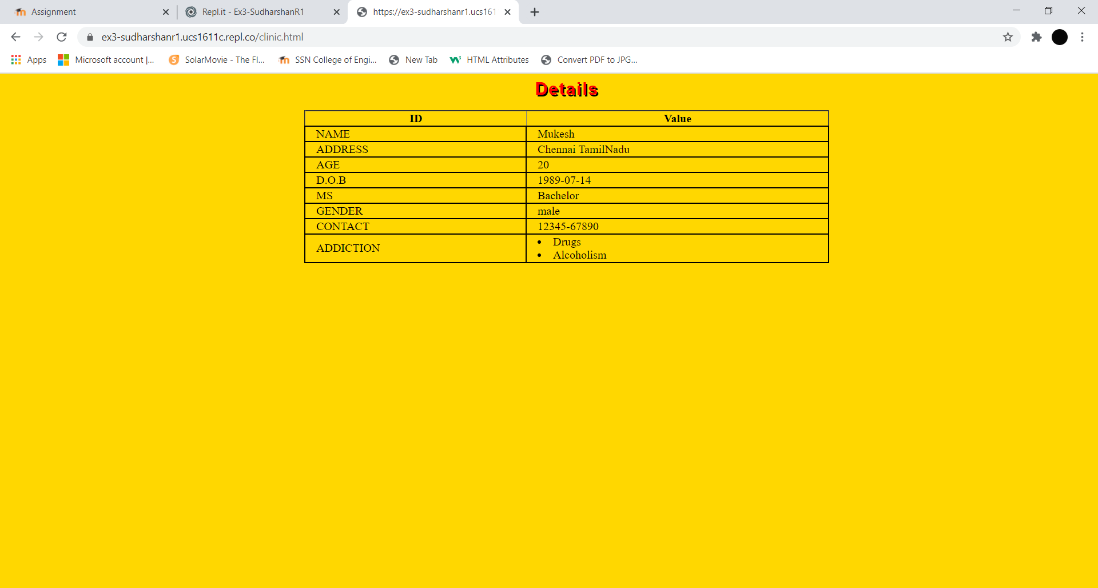

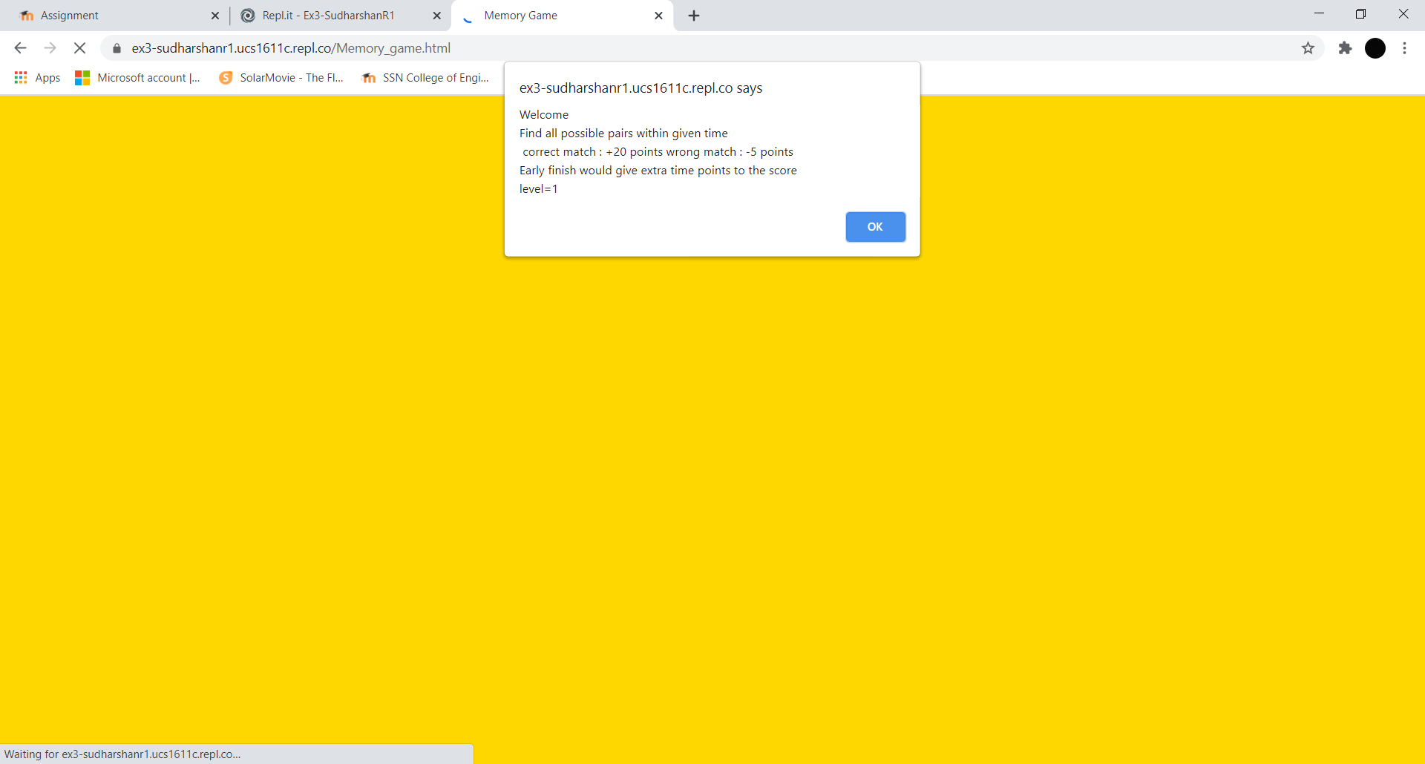

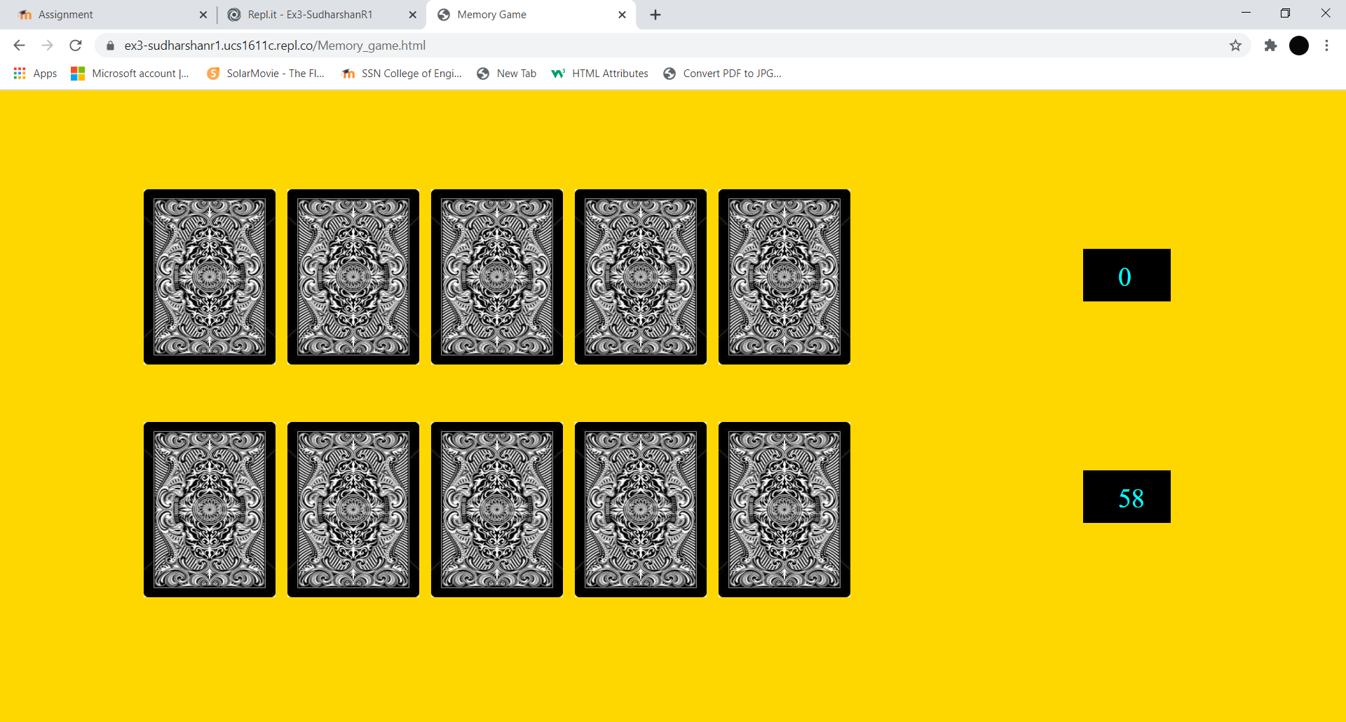

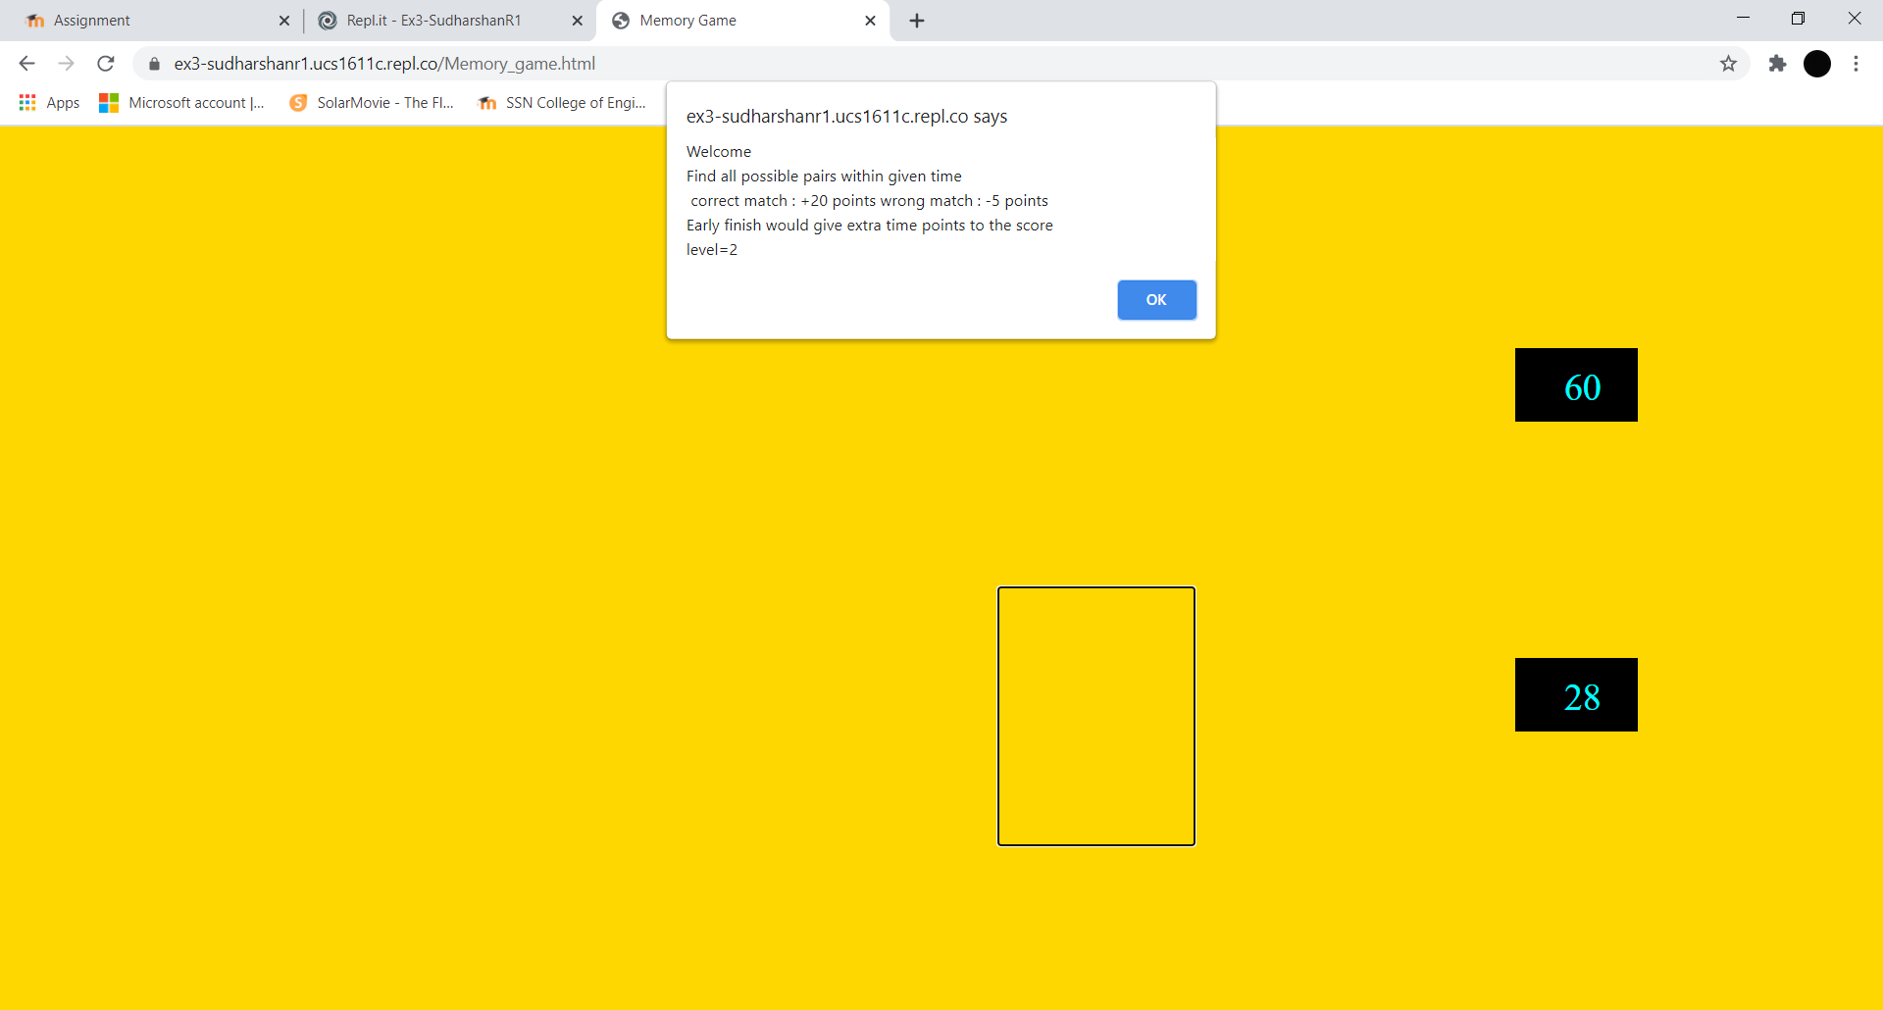

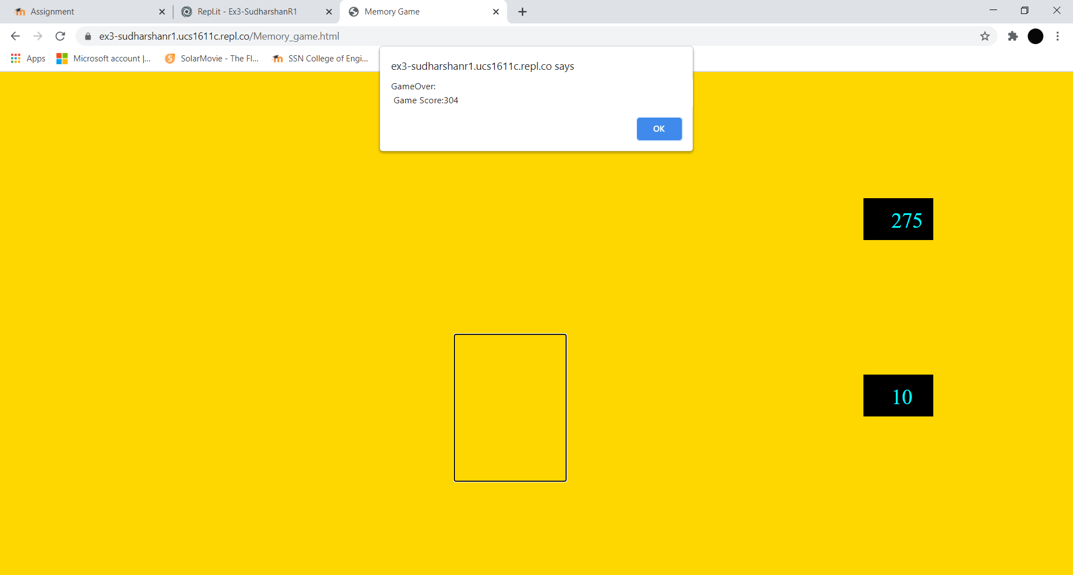

**LEARNING OUTCOME:**

* I learnt about the different events and event handlers.
* Also learnt to implement event listener and how to add it to code.
* Understood the usage of different event elements.
* Understood html image hiding and changing source.
* Learnt about the absolute and relative positioning.
* Learnt on how to validate form elements and show them on a new window.